**GCD (Prime Factorization)**

**Code**

#include<bits/stdc++.h>

using namespace std;

void Intersection(int arr1[], int arr2[], int m, int n)

{

int mult=1;

int i = 0, j = 0;

while (i < m && j < n)

{

if (arr1[i] < arr2[j])

i++;

else if (arr2[j] < arr1[i])

j++;

else

{

mult = mult * arr2[j];

i++;

j++;

}

}

cout<<"The GCD is: "<<mult<<" (Prime Factorization) "<<endl;

}

int PrimeFactor(int a, int b)

{

int MAX,len1,len2;

int PF1[10];

int PF2[10];

int divisor1 = 2,divisor2 = 2,i=0,j=0,cPF1=0,cPF2=0;

while(a>1)

{

while(a%divisor1 == 0)

{

cPF1++;

PF1[i++] = divisor1;

a = a / divisor1;

}

divisor1++;

}

while(b>1)

{

while(b%divisor2 == 0)

{

cPF2++;

PF2[j++] = divisor2;

b = b / divisor2;

}

divisor2++;

}

int m = sizeof(PF1)/sizeof(PF1[0]);

int n = sizeof(PF2)/sizeof(PF2[0]);

Intersection(PF1,PF2,m,n);

}

int main()

{

int a,b,m;

cout<<"Enter a number: ";

cin>>a;

cout<<"Enter another number: ";

cin>>b;

PrimeFactor(a,b);

return 0;

}

**Output**

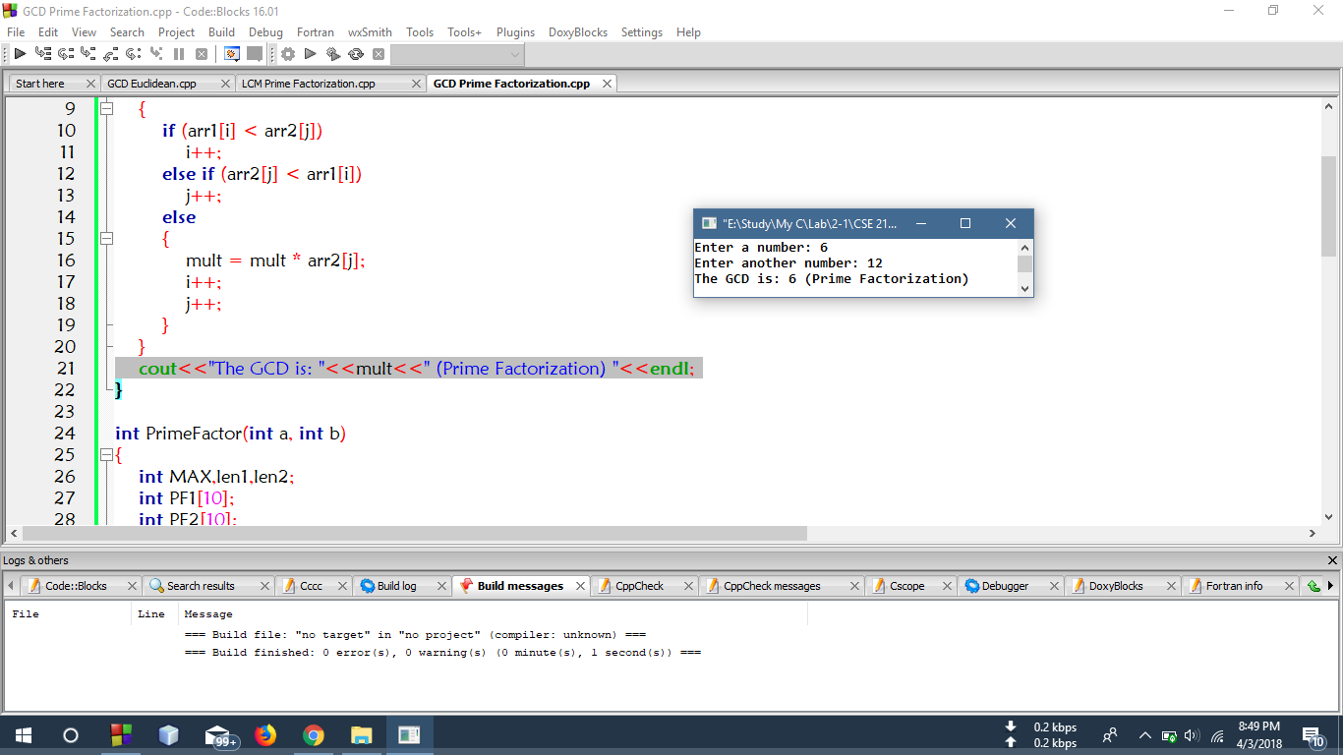

**GCD (Euclidean Method)**

**Code**

#include<bits/stdc++.h>

using namespace std;

void GCDEuclid(int a, int b)

{

int r;

int x = a;

int y = b;

while(y !=0)

{

r = x % y;

x = y;

y = r;

}

cout<<"The GCD is: "<<x<<" (Euclidean Method)"<<endl;

}

int main()

{

int a,b;

cout<<"Enter a number: ";

cin>>a;

cout<<"Enter another number: ";

cin>>b;

GCDEuclid(a,b);

return 0;

}

**Output**

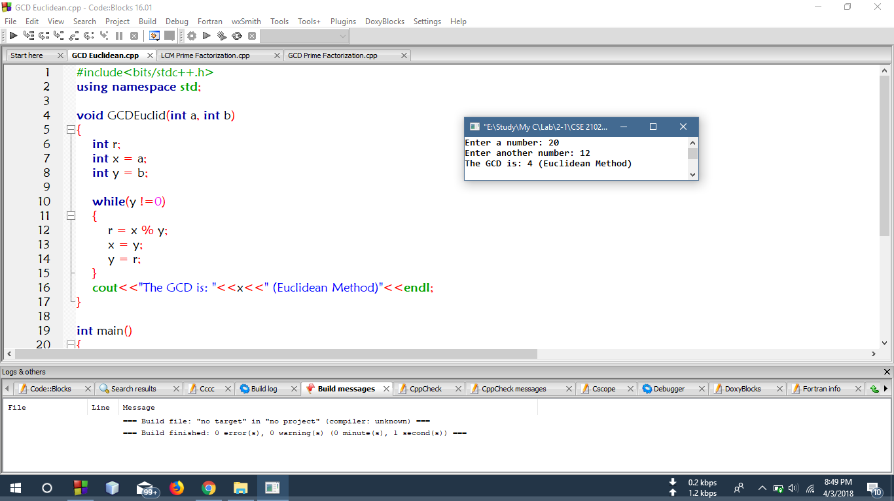

**LCM (Prime Factorization)**

**Code**

#include<bits/stdc++.h>

using namespace std;

void Union(int arr1[], int arr2[], int m, int n)

{

int i = 0, j = 0,mult=1;

while (i < m && j < n)

{

if (arr1[i] < arr2[j])

mult = mult * arr1[i++];

else if (arr2[j] < arr1[i])

mult = mult * arr2[j++];

else

{

mult = mult * arr2[j++];

i++;

}

}

while(i < m)

{

mult = mult * arr1[i++];

}

while(j < n)

{

mult = mult * arr2[j++];

}

cout<<"The LCM is: "<<mult<<" (Prime Factorization) "<<endl;

}

int PrimeFactor(int a, int b)

{

int len1,len2;

int PF1[3];

int PF2[2];

int divisor1 = 2,divisor2 = 2,i=0,j=0,cPF1=0,cPF2=0;

while(a>1)

{

while(a%divisor1 == 0)

{

cPF1++;

PF1[i++] = divisor1;

a = a / divisor1;

}

divisor1++;

}

while(b>1)

{

while(b%divisor2 == 0)

{

cPF2++;

PF2[j++] = divisor2;

b = b / divisor2;

}

divisor2++;

}

int m = sizeof(PF1)/sizeof(PF1[0]);

int n = sizeof(PF2)/sizeof(PF2[0]);

Union(PF1,PF2,m,n);

}

int main()

{

int a,b,m;

cout<<"Enter a number: ";

cin>>a;

cout<<"Enter another number: ";

cin>>b;

PrimeFactor(a,b);

return 0;

}

**Output**

